FORUM RUSNANOTECH

26-28.10.2011, Expocenter, Moscow
 |  | 

The address of Expocentre: 14, Krasnopresnenskaya nab., Moscow.

Hotel | Room | Price  Room per day (in EUROS) | Breakfast
Hotel “Aerostar Hotel Moscow”****  Address: Leningradskiy prospekt, 37, bldg. 9  Nearest metro station: Dinamo - Zamoskvoretskaya line - 0,4 km | - Single  - Twin | 155  172 | Buffet breakfast included
Other room categories in request.

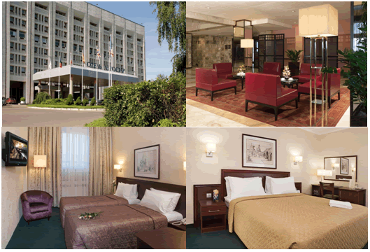
Transport services
Transport | Transfer airport-hotel | Transfer railway station-hotel | Rent prices
Сar (3 seats sedan) | 44 Euros | 36 Euros | 25 Euros per hour
Microbus 6 seats | 128 Euros | 115 Euros | 25 Euros per hour
Microbus 17 seats | 105 Euros | 95 Euros | 25 Euros per hour
Minimum 4 hours plus 1 extra hour.

127055 , Russia, Moscow, Tikhvinsky per., 11 bldg. 2

Tel./fax. +7 (495) 961 11 99
Contact: Julia Subbotina, e-mail: j.subbotina@concordgroup.ru

APPLICATION FORM

Full Participants Name:
Post/ Actual address:
Fax
E-mail

Accommodation in hotels
Hotel | Second name | Date and check in time | Date and check out time | Room category | Rooms number

Transfer airport (railway station) – hotel/ hotel-airport (railway station)
Airport / railway station | Transport | Arrival/departure date | Arrival time | Flight number/ Train number | Number of persons and baggage
The driver with a Name Board ____________________________will wait for you in the arrival lounge in the airport or at the head train carriage at the railway station

Rent of a car with a driver in the city
Pick-Up date | Pick-Up time | Car rent hours | Car type | Pick-Up place | Name Board

Method of payment Cashless settlement Credit card

Cashless settlement payment
Please fill in the form below

Name of the Company (to issue invoice to)
Telephone/fax
E-mail

Payment by credit card
Please fill in the form below

Name of holder
Choose the type of credit card | VISA Master card
Number of credit card
Valid till

Common conditions and order of payment
- Check out in the hotel – 12.00, check in – 15.00
- In case of arrival earlier than “check in” the accommodation is not guaranteed
- In case of departure after the “check out” the payment is made according to the hotel’s rates
- 100% payment against an invoice should be made during 5 bank’s days from the date of issue a bill. Otherwise the reservation is not actual.
- The performer issues the account to the customer within 2 days from the moment of signing the invoice.
- Payment by credit card is subject to a commission of 5%

Refusal from hotel reservation:
- Paid off sum is not refunded in case of cancellation of accommodation or reduction after 20.09.2011.
- Paid off sum is not refunded in case of cancellation of transport services after 17.10.2011.

We agree by actual application form with the rules and states of the hotel booking.
A Contractor and Customer agree to consider this properly adjusted application a treaty of providing services.

Customer: Contractor:
__________________________________ | LLC ConcordBusinessService  BSRN 1027700482534  TIN 7734147578 KPP 774301001  Legal address: corp. 1, 11, pr. Staropetrovskiy, Moscow, 125130  A/n 40702810800000001741 in OAO MBK «Zamoskvoretskiy» Moscow  C/a 30101810400000000636; BIC 044583636  phone/fax: +7 (495) 737-05-66

__________________/________________/ _________________/Ikonnikov K.A./
«____»_____________2011 г. SP «____»________________2011 г.

